Java Managemnt Fleet With ORM stack

Contents

1. Introduction 3
2. .Workflow diagram to deploy the stack 3
3. Create stack for Java Management Fleet 4
4. Plan the Job 7
5. Apply the Job 8
6. Verify in the Console 9
7. Destroy the stack 12

Introduction

Java Management Service (JMS) is a native Oracle Cloud Infrastructure (OCI) service that monitors Java deployments on OCI instances and instances running in customer data centres. It enables the observe and manage the use of Java in enterprise.
This resource provides the Fleet resource in Oracle Cloud Infrastructure JMS service.

.Workflow diagram to deploy the stack

Below diagram shows how the Terraform Artifact are applied in the OCI. While creating a ORM stack, using terraform deliverables Init, Plan and Apply is the flow to provision the resource in the OCI. We can have the deliverables in any of below.

- GitLab/GitHub Repo
- Bitbucket
- Can be in folder/.zip in the local disk
- Object Storage Bucket
- Can be in compartment
- Oracle provided Template


Create stack for Java Management Fleet

Go to OCI Console Developer Services Resource Manager Stacks select the compartment Create Stack

My Configuration Folder Browse Select the “Fleets” folder that contains the terraform Upload

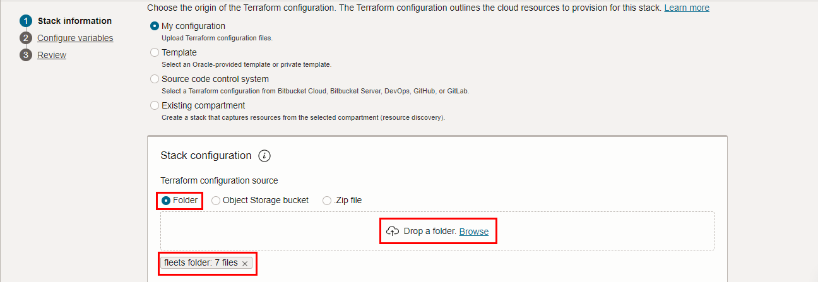

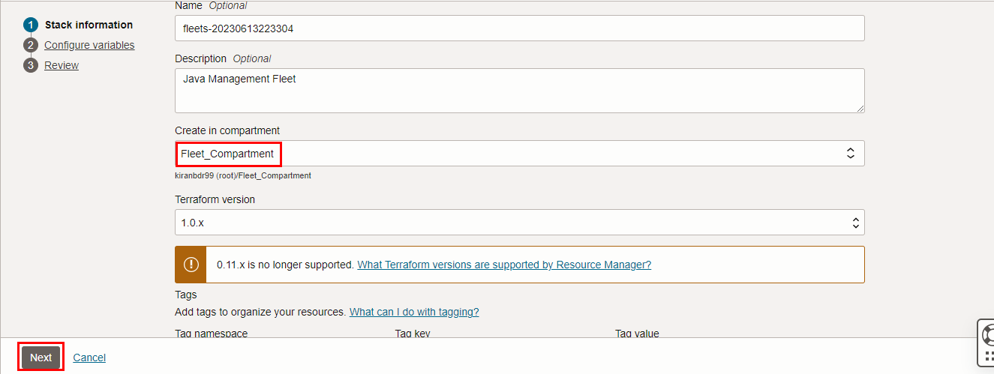
Select the parameters as per the below screen,
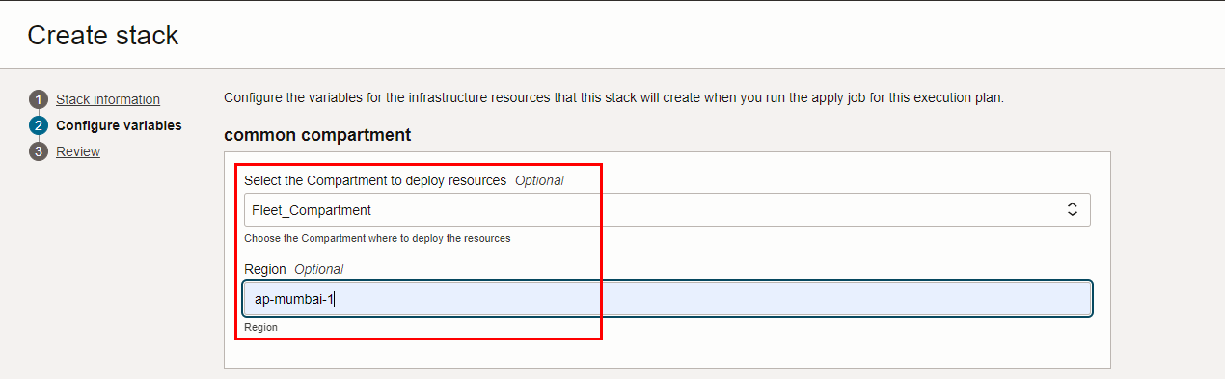

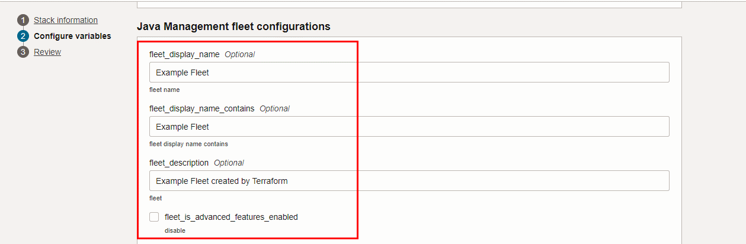

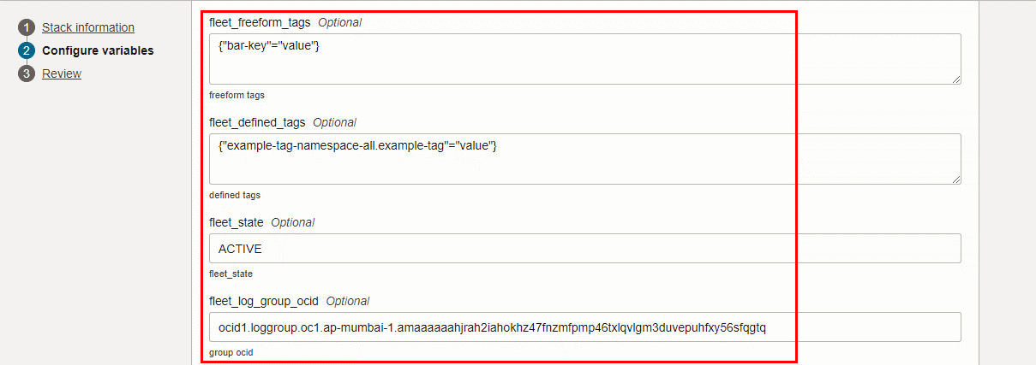

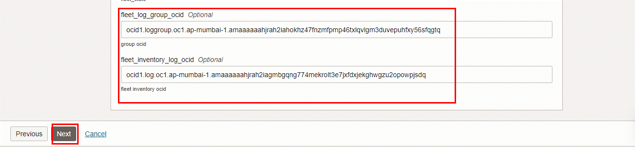
Click “NEXT”

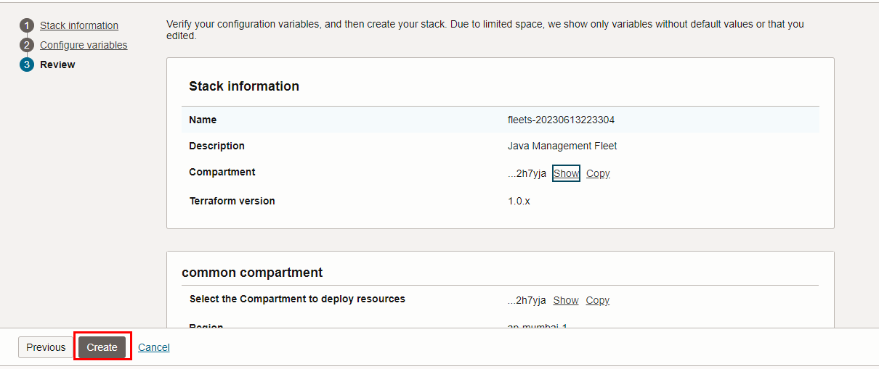
Click “CREATE”

Plan the Job
Click the “Plan”
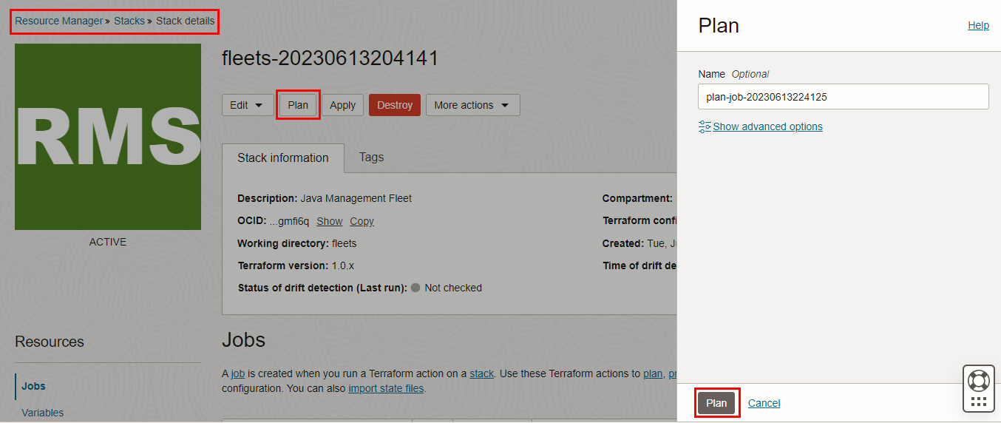

Verify the Plan is successful.
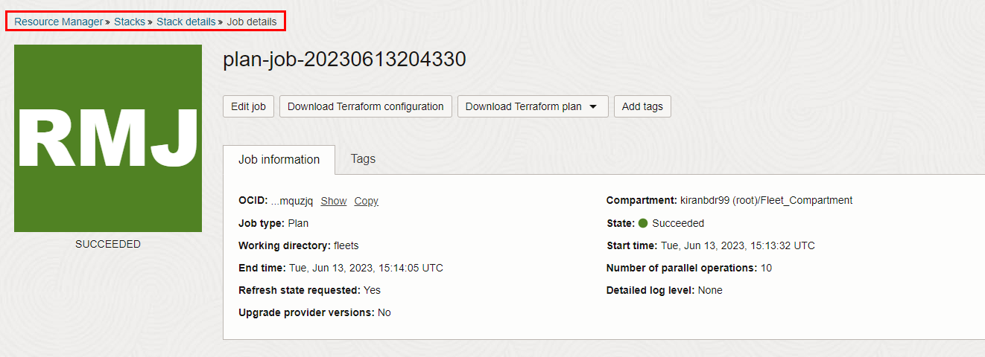
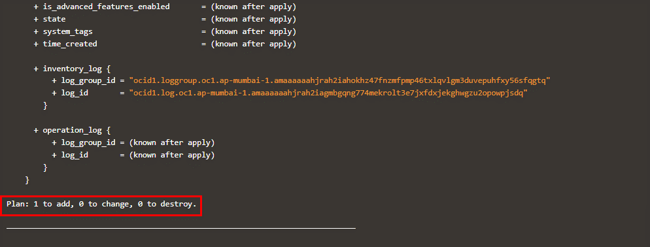

Apply the Job

Once the “plan” is success, now click “Apply”
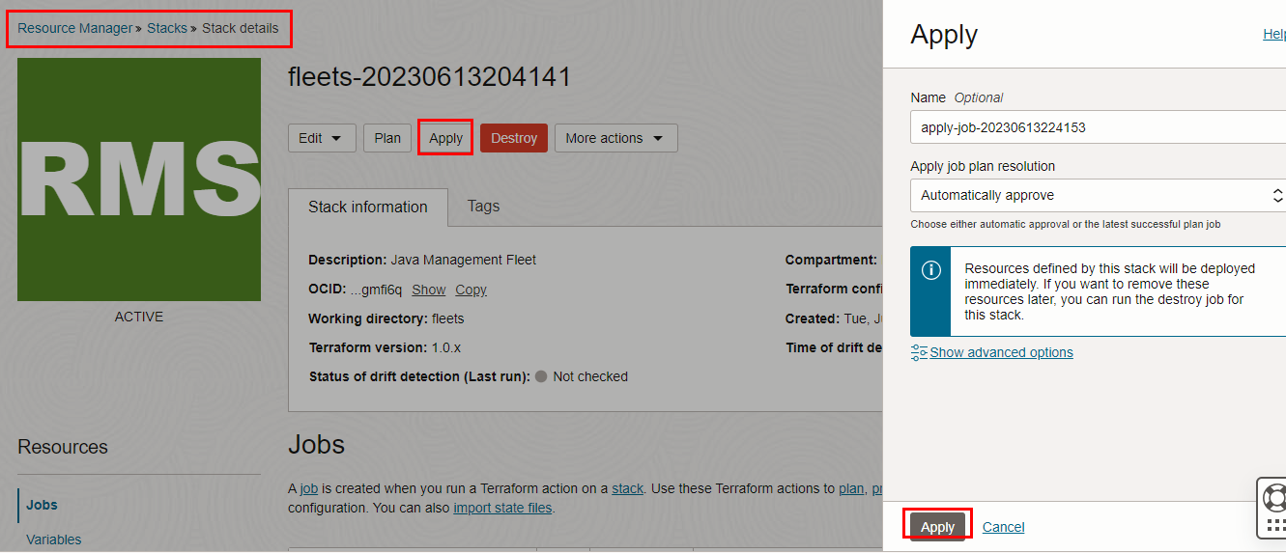

Verify the Apply is successful.
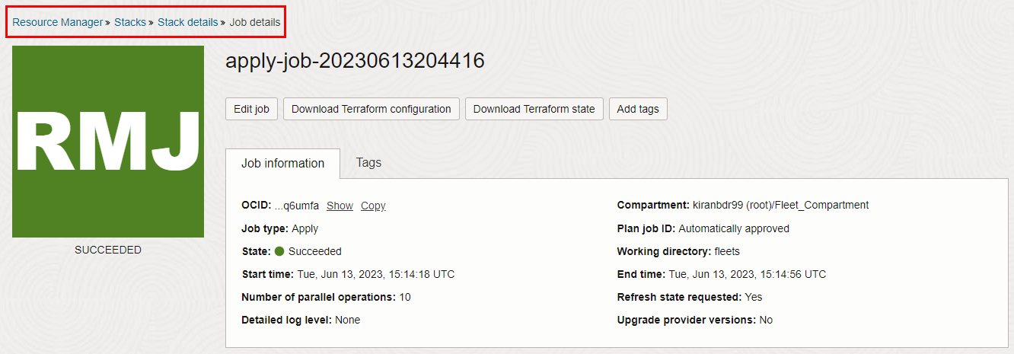
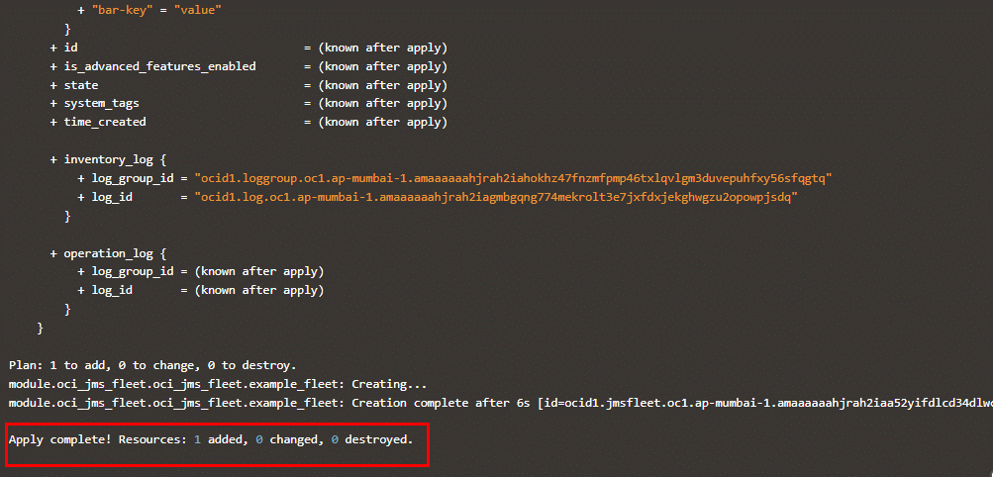

Verify in the Console

Go to OCI Console Observability & Management Java Management AgentFleets

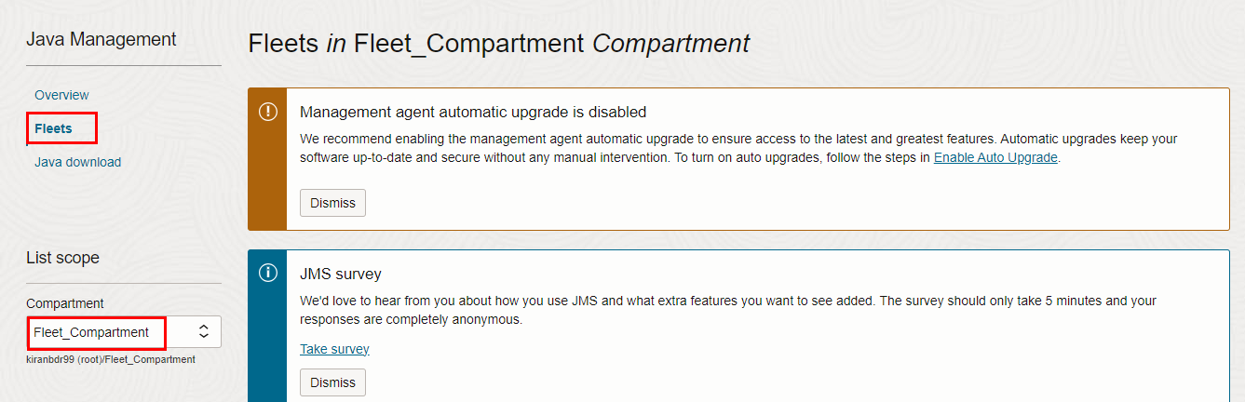

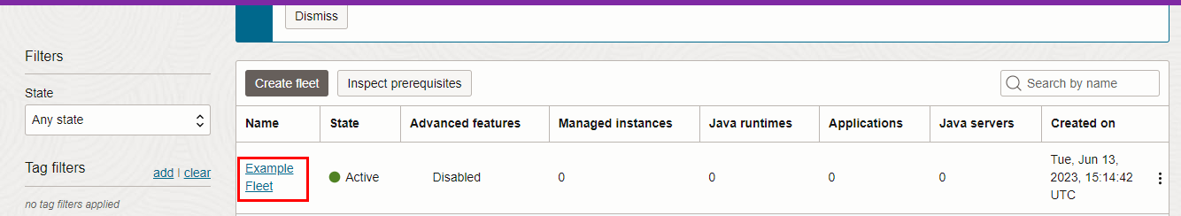

Fleet Management Example Fleet details
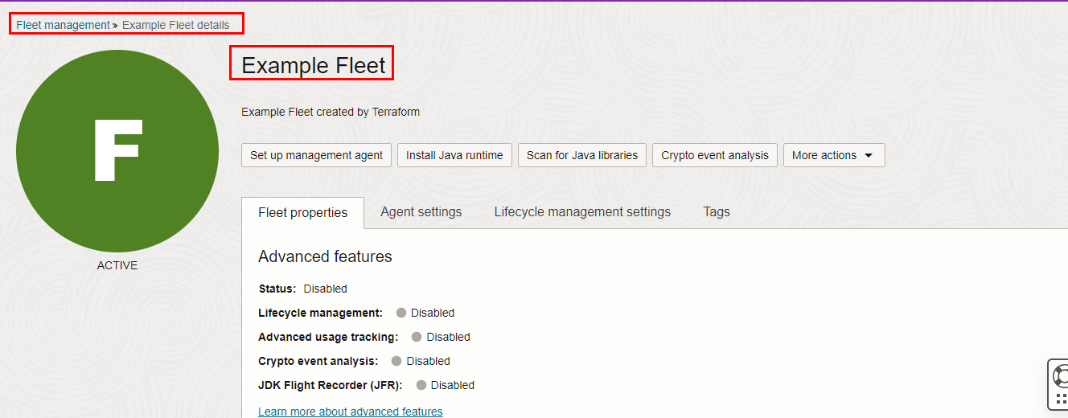

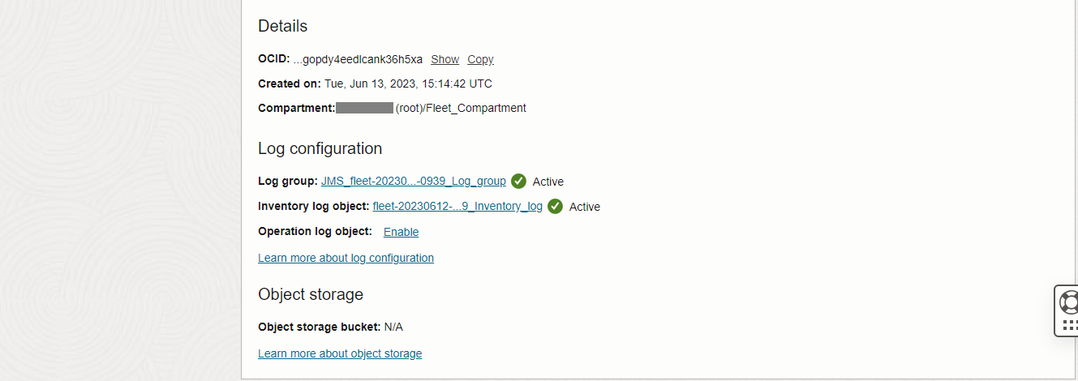

Go to OCI Console Observability & Management Logging Log Groups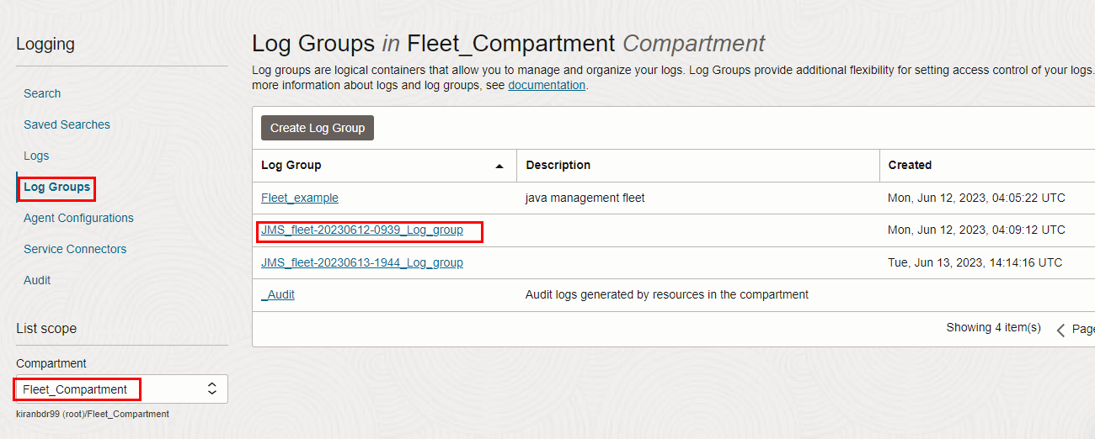

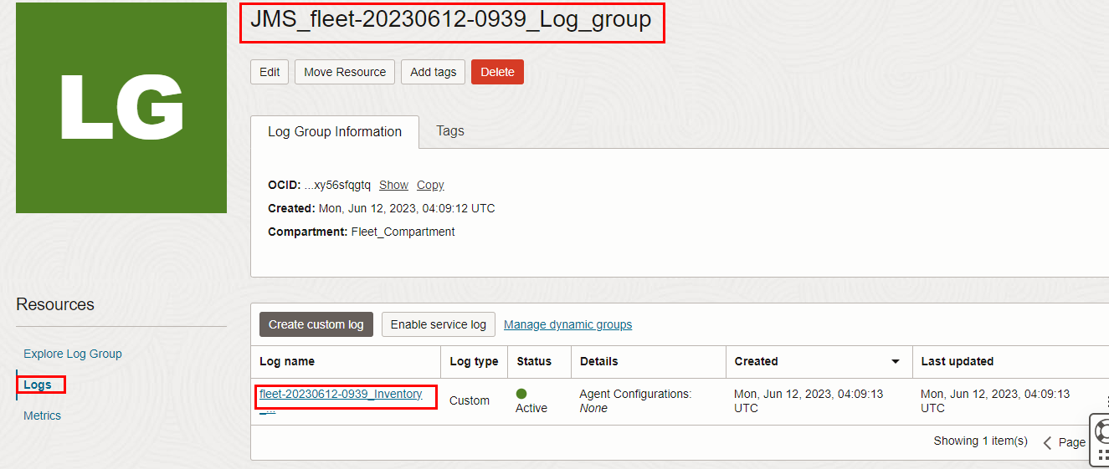

Observability & Management Logging Log
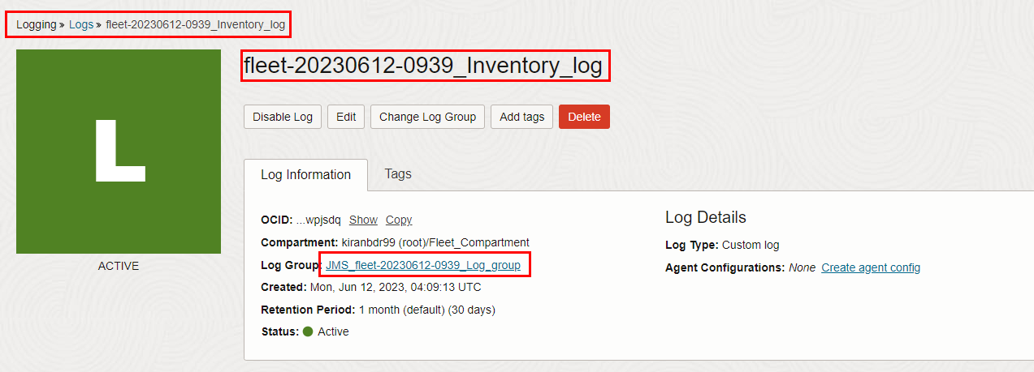

Destroy the stack

Create a destroy job in Resource Manager to release resources associated with a stack and clean up the tenancy. Once destroyed data cannot be recovered from resources.

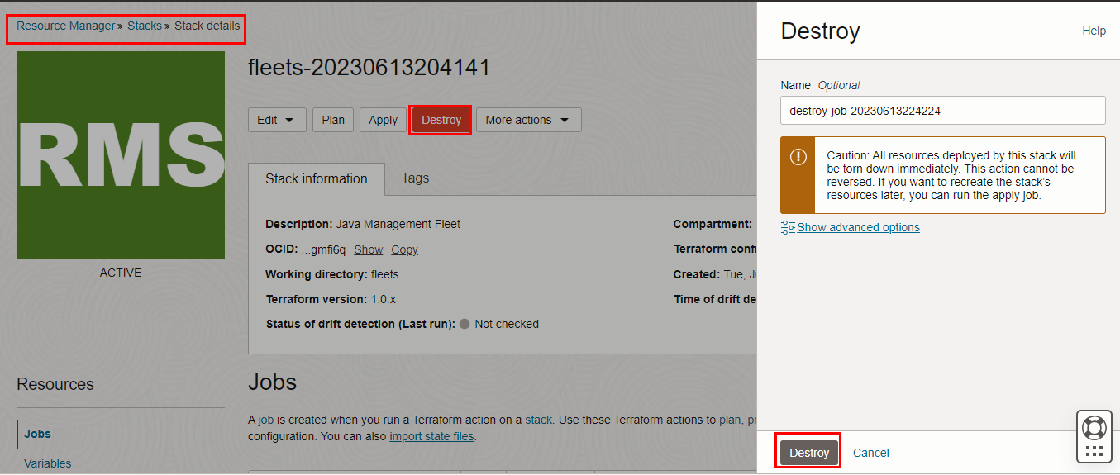

#END#

